

**User Manual**

Department of Veterans Affairs,

Pre-Procedure Checklist Tool

VA118-11-RQ-0508

**Intellica Corporation**

**209 W. Poplar**

**San Antonio, Texas 78212**

**02/19/2013**

Table of Contents

User Manual Version Log 5

Introduction 6

Logging on 7

Home View 8

Variable Editor 9

Creating a New Variable 10

Editing a Variable 12

Item Editor 13

Creating a New Item 13

Laboratory Type Items 14

Question Selection Type Items 17

Note Title Type Items 18

Collection Type Items 19

Editing an Item 20

Checklist Editor 22

Creating a New Checklist 23

Mapping Checklist to Note Title 24

States and Logic Editor 28

Editing a Checklist 34

Assign Checklist 36

Patient Lookup 40

Single Patient View 42

Updating Items 44

Collection Items 45

Overriding Decision State 49

Writing Checklist Contents to TIU Note 51

New Version Available 52

Multi Patient View 54

Multi Patient View Refresh 56

Apply New Checklist Version to Multiple Patients 58

Single Patient Editor 59

**Table of Figures**

Figure 1 - Login Page 7

Figure 2 - Login Dialog 7

Figure 3 - Navigation Toolbar 8

Figure 4 - Home View 8

Figure 5 - Variable Editor Page 9

Figure 6 - New Variable 10

Figure 7 - Example New Variable Dialog 11

Figure 8 - Editing Variable 12

Figure 9 - State Variable Dialog edit 12

Figure 10 - Item Editor 13

Figure 11 - Mapping Lab Item to VistA 14

Figure 12 - Map Lab dialog 15

Figure 13 - Item Editor Dialog: Laboratory Items 16

Figure 14 - Item Editor Dialog: Question Selection Items 17

Figure 15 - Item Editor Dialog: Note Items 18

Figure 16 – Item Editor Dialog: Collection Items 19

Figure 17 - Item Editor Page 20

Figure 18 - Pre-populated Item Editor Dialog 21

Figure 19 - Checklist Editor 22

Figure 20 - Checklist Editor New Checklist 23

Figure 21 - Checklist Editor: Mapping to Note Title 24

Figure 22 - List of Note Titles 24

Figure 23 - Item Selector Dialog 25

Figure 24 - Checklist Editor with Item 26

Figure 25 - Checklist Editor Collapsed Checklist Fields 27

Figure 26 - Accessing State/Logic Editor 28

Figure 27 - Checklist State/Logic Editor Dialog 29

Figure 28 - State/Logic Editor 30

Figure 29 - State/Logic Editor: Operators 30

Figure 30 - Selecting that Patient Sex is a Parameter 31

Figure 31 - Selecting that Patient Sex must be Female 32

Figure 32 - Selecting the Action is to set the Decision State to Go 33

Figure 33 - Checklist Editor Saving/Loading 34

Figure 34 - Checklist Selector Dialog 35

Figure 35 - Save Checklist as New Checklist dialog 35

Figure 36 - Assign Checklist page 36

Figure 37 - Checklist Selector Dialog 37

Figure 38 - Assign Checklist: Patient Selected 38

Figure 39 - Warning Message Duplicate Checklists 39

Figure 40 - Cancel Processing 39

Figure 41 - Patient Lookup Page 40

Figure 42 - Patient Lookup: Patient Selected 41

Figure 43 - Single Patient View 42

Figure 44 - Single Patient View with Open Checklist 43

Figure 45 - Single Patient Item Editor 44

Figure 46 - Data Historical Trend 45

Figure 47 - Collection Item Quick Entry 45

Figure 48 - Entering Updates Quick Entry 46

Figure 49 - Checklist with Collection Items 46

Figure 50 - View Values 47

Figure 51 - Collection item Values View 48

Figure 52 - Override Patient Checklist Item State 49

Figure 53 - Single Patient View with Open Checklist 50

Figure 54 - Single Patient View TIU Note 51

Figure 55 - Sample TIU Note 51

Figure 56 - New Version Available 52

Figure 57 - Update Version Dialog 52

Figure 58 - Version is Current 53

Figure 59 - Multi Patient View 54

Figure 60 - Search Results Multi Patient View 55

Figure 61 - Data Refresh 56

Figure 62 - Cancel Processing 56

Figure 63 - View After Collapsing Filters 57

Figure 64 - Apply New Version 58

Figure 65 - Apply New Version: Select Patients 58

Figure 66 - Single Patient Editor accessed from Multi Patient View 59

# 

# User Manual Version Log

|  |  |  |  |
| --- | --- | --- | --- |
| Date | Version | Author | Revision Description |
| 1/26/2012 | 1.0.0 | Marisol Smith | Created (Sprint 3, First Prototype Delivery) |
| 2/26/2012 | 1.0.9 | Marisol Smith | Added ‘Assign Checklist’, ‘Patient Lookup’, Updated previous sections |
| 3/26/2012 | 2.0.0 | Marisol Smith | Added new features in ‘Single Patient’, ‘Patient Lookup’, ’Assign Checklist’ |
| 4/25/2012 | 2.1.2 | Marisol Smith | Added ‘Multi Patient View’ |
| 5/25/2012 | 2.2.0 | Marisol Smith | Updated previous sections to include ability to map and write to VistA and other new features |
| 6/14/2012 | 2.2.8 | Marisol Smith | Updated Single Patient View explanation of summary indicators, updated screenshots |
| 6/25/2012 | 2.3.8 | Marisol Smith | Updated figures to reflect section 508 compliance changes, updated Lab Items. |
| 7/24/2012 | 2.6.0 | Marisol Smith | Updated figures with requested changes, section 508 compliance |
| 8/23/2012 | 2.7.1 | Marisol Smith | Updated Login Dialog figure, updated text |
| 9/24/2012 | 2.9.3 | Marisol Smith | Updated text and figures, including cancel option, toggle feature and scrolling. |
| 10/22/2012 | 2.9.7 | Marisol Smith | Updated text and figures including sorting of Items and trend. |
| 11/19/2012 | 3.3.5 | Marisol Smith | Updated text and figures to reflect layout changes, checklist version updating. |
| 12/20/2012 | 3.4.3 | Marisol Smith | Updated figures. |
| 1/22/2013 | 3.4.7 | Marisol Smith | Updated figures, text. |
| 2/15/2013 | 3.7.2 | Marisol Smith | Updated manual with feedback, included Quick Entry information |
| 2/19/2013 | 3.7.2 | Marisol Smith | Added figure/text regarding Values view Quick Entry |

# Introduction

The Pre-Procedure Checklist Tool is a software application being developed by Intellica Corporation for the Department of Veterans Affairs under solicitation: VA118-11-RQ-0508. All development, testing, and demonstration of the prototype are being done exclusively in the VA Innovations Sandbox. The prototype provides for the generation of, and graphical representations of, pre-procedure checklists. This checklist displays patient attributes based on existing VistA fields.

# Logging on

A User Name and Password are required to gain access to the application. Users can use their Vista username and password to log on to the application.

# Login Main Page.png

**Top left corner of Login Page**

**Click here to open Login Dialog**

Figure 1 - Login Page

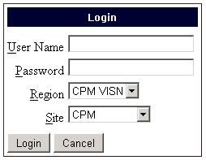

**Enter User Name and Password, Specify**

**Region and Site,**

**Click ‘Login’**

Figure - Login Dialog

The User enters their username and password and selects their region and site, in order to log in to the application. The application has a time out period of 20 minutes. After 20 minutes of user inactivity the User is logged off the system and will need to log on again.

# Home View

The Home View is the default page to which the application navigates after the User logs in. The Home View has a navigation toolbar across the top with links to all the other pages in the application. In the upper right hand corner of the view the currently logged-in user is displayed, along with the date and time of the login. A log-off button is available in this area as well. The navigation and logging options remain available in all the pages in the application.

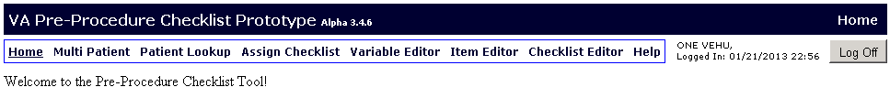

Figure 3 - Navigation Toolbar

The navigation links on the toolbar allows user to have access to:

Home

Multi Patient View

Patient Look Up Page

Assign Checklist Page

Variable Editor Page

Item Editor Page

Checklist Editor Page

Help Page

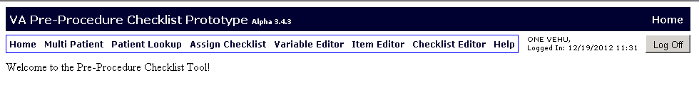

Figure - Home View

**Login information**

# Variable Editor

In the Variable Editor Page the User maintains variable data used by the Item Editor. The User may define Temporal States, Outcome States, Decision States, Item Groups, and Services on this page.

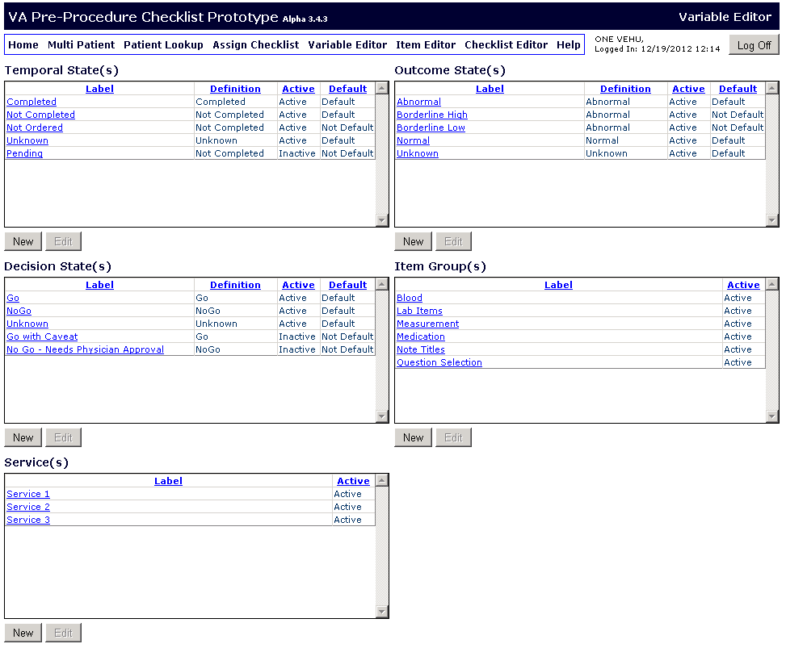

Figure - Variable Editor Page

The Temporal State variables define the possible state of an item. The Outcome State variables define the resultant state of an item. The Decision State variables define a rule-based state for an item (e.g. Go or No Go). A set of default variables is automatically included in each of the state variable lists. The Item Groups are used by the application in the ‘Multi Patient View’ to aggregate the statuses of multiple items into one group value, allowing the User to collapse or expand groups as needed for comparison. The Services are used to group checklists.

## Creating a New Variable

The User can click on the ‘New’ button below a list of variables to add a new state, item group or service variable. This will cause the corresponding state or item group editor dialog to appear.



**Click ‘New’ to add new variable to list**

Figure - New Variable

The User needs to enter a label for the new variable. The Temporal State, Outcome State, and Decision State variables also require a definition that can be selected from a drop down list. The definitions serve to tell the application how to interpret the variable when it is selected in a patient’s checklist. Definitions cannot be edited or created. For example, the User can create and outcome label of ‘Critical High’ and define it as abnormal. If a checklist item has an outcome state value of ‘Critical High’, the application knows to flag the item as abnormal.

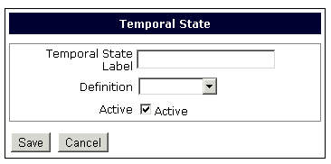

Figure - Example New Variable Dialog

The User can indicate if they want the variable to be active by placing a checkmark in the ‘Active’ checkbox (removing the check causes the variable to be inactive, thus not show up in other parts of the application). The User can click the ‘Save’ to save the new variable.

## Editing a Variable

The User also has the ability to edit variables, although the default variables cannot be edited.

First, the User must select the variable they wish to edit by clicking on it. Once the desired variable is highlighted, they can click on the ‘Edit’ button located below the list of variables.

. 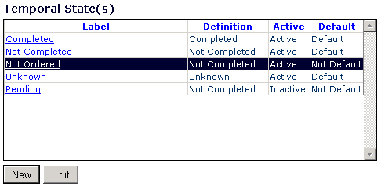

**Select**

**Variable and**

**click ‘Edit’**

Figure - Editing Variable

This will prompt the corresponding variable dialog to pop up prefilled with the selected variable’s information. The User can make desired changes and click ‘Save’ when done.

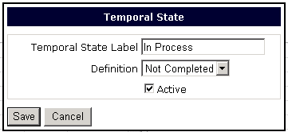

Figure - State Variable Dialog edit

# Item Editor

In the Item Editor page the User creates checklist items for use in the Checklist Editor. A User may add or edit items (including designating them as active or inactive). The User can search for current items filtering by Item Label, Item Type, and Item Group.

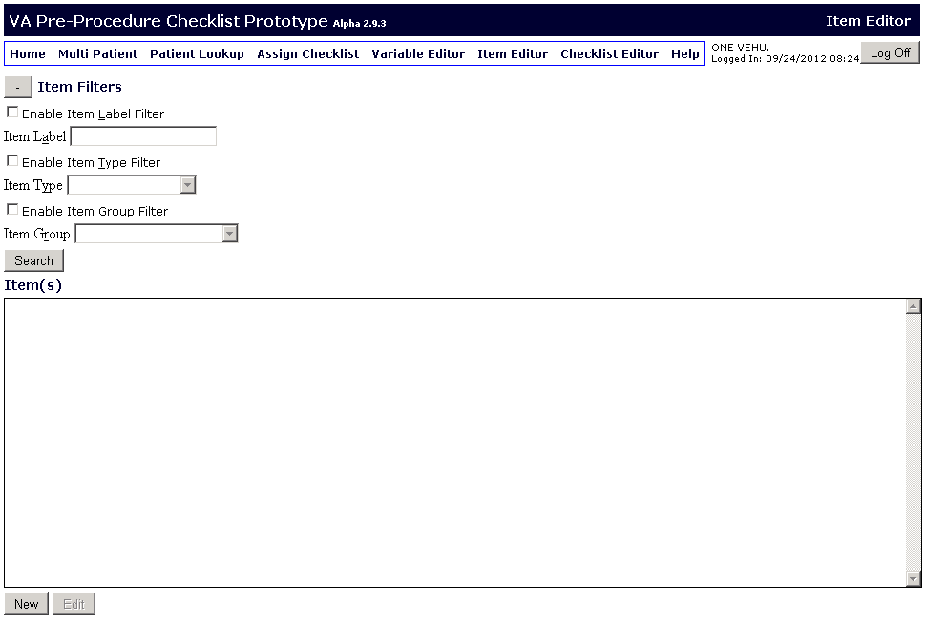

**Click on ‘New’ to open ‘item Editor’ dialog to create a**

**new item**

Figure - Item Editor

## Creating a New Item

The User can click on the ‘Add Item’ button to add a new item. The ‘Item Editor Dialog’ will pop up. For each item the User can select an item type, group, item label, description, lookback time (in days), and select whether the item is active or inactive.

The item type describes whether the item is, for example, a laboratory test or a question with selections or free text answer. The item group serves to group items in the multi-patient view to allow for data compression for easier viewing. The description field is a free text area where the User can describe the item being created. The lookback time is the amount of previous days the application will include in its search for data values for that item. This data will be stored locally and will allow for quicker retrieval of data for the checklists.

### Laboratory Type Items

The User can create Laboratory type items by selecting ‘Laboratory’ from the drop down ‘Type’ menu. This will enable the ‘Map’ button that will allow the User to map the item to the corresponding VistA test.

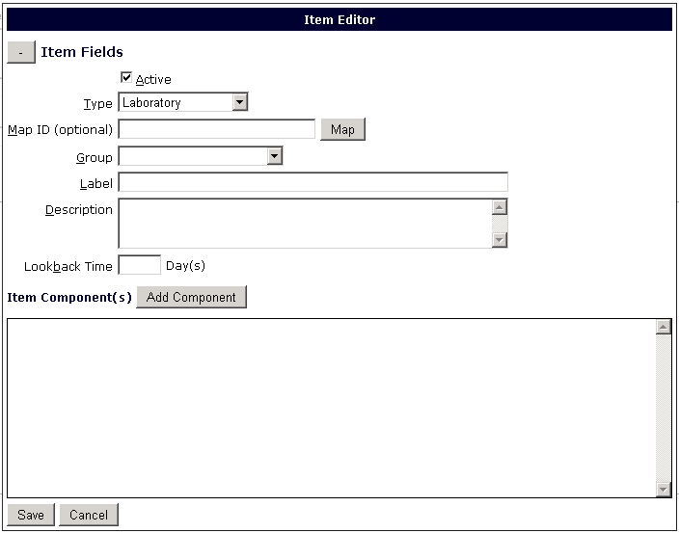

**User can click on ‘Map’ to map the item to VistA test**

Figure - Mapping Lab Item to VistA

The User will then be able to select the desired VistA test in the Map Lab Test dialog that appears. The User can enter a search term and click ‘Search’ on the top right to narrow the results. To make a selection the User clicks on the desired test (it will become highlighted) and clicks ‘Select’.

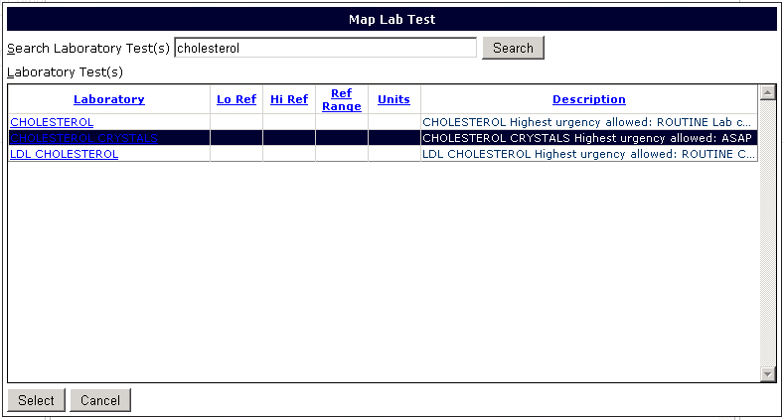

Figure - Map Lab dialog

After selecting the test, the User will be brought back to the Item Editor where the User can enter the acceptable value ranges and other pertinent information for the lab item. The User can click ‘Save’ on the bottom left when done.

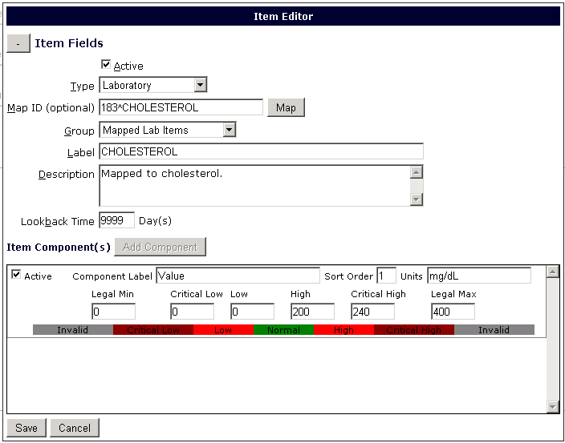

**Component**

**Fields for items with ‘Laboratory’ item Type**

Figure - Item Editor Dialog: Laboratory Items

### Question Selection Type Items

For ‘Question Selection’ type items the User defines a ‘State’ to be associated with the label instead. The state allows the application to know if a positive for the component is a positive or negative for the item (which would lead to Go/No Go). Available States are hard coded as ‘Good’, ‘Bad’, or ‘Unknown’ and cannot be edited. If a component with a ‘Good’ state is selected in a patient’s checklist, the application will know it is a positive for the item.

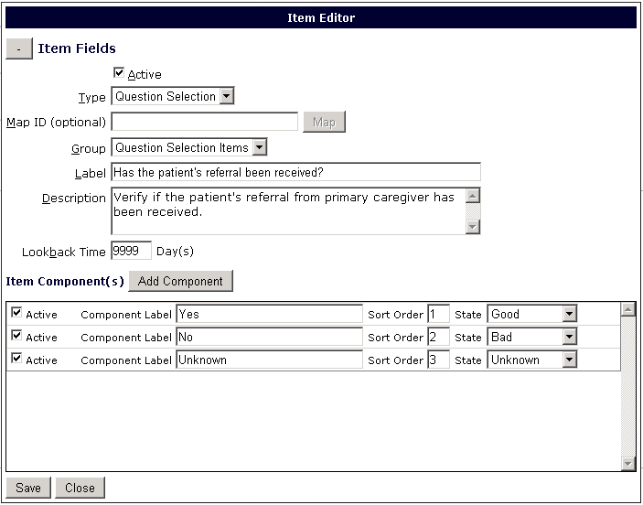

**Component**

**Fields for items with ‘Question Selection’**

**item Type**

Figure - Item Editor Dialog: Question Selection Items

Once the User has completed the item, they can click ‘Save’. The dialog will remain open for any further changes until the User clicks ‘Cancel’.

### Note Title Type Items

The User can create a Note type item and map it to a note title from VistA as well. The Note Title will become the Item Label.

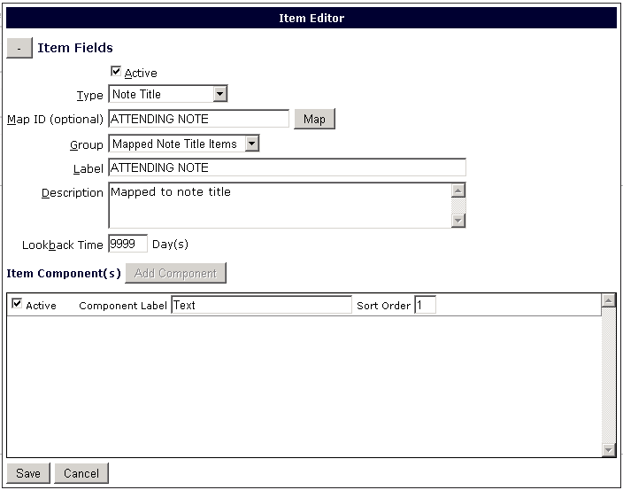

**Click Map to open list of VistA Note Titles**

**Note Title will populate the item Label field**

Figure - Item Editor Dialog: Note Items

The User can also create an item that is a collection of other items (of any type). The User can select Collection as the item type. The User can then click on the ‘Add Item’ button to open the ‘Item Selector’ dialog to access a list of active items. The User can select an item from this list and add it as a component. The User can then click ‘Add Item’ again and repeat the process until all the desired items have been added as components.

### Collection Type Items

The User can create a Collection Type Item in which a set of items can be included as one single item in a Checklist. The User selects Collection as the type of item and then will be able to click on ‘Add Item’ to add items to the collection. When clicking ‘Add Item’ an item selector dialog appears and allows the User to select an item that should be included in the collection. The lookback time will remain 0 since the lookback time for each individual item can be different (and was already assigned when the particular item was created).

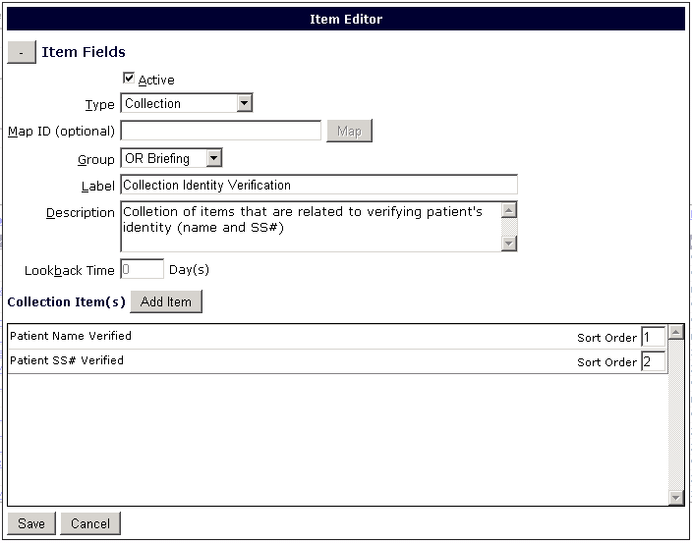

**Click Add item to add items to Collection**

Figure – Item Editor Dialog: Collection Items

## Editing an Item

The User also has the ability to edit an existing item. The User can search for current items filtering by Item Label, Item Type, and Item Group. There are check boxes next to each filter to allow the User to select one or more filters for the search, and then select the relevant data from the drop down menus. After selecting the filters the User clicks ‘Search’. A list will be displayed will all qualifying items. The User can click on the toggle button to collapse the filter area and include more of the search results in their screen. Once the User has found the item, the item needs to be selected by clicking on the item label. The User can now click on ‘Edit’ to open the Edit Item dialog.

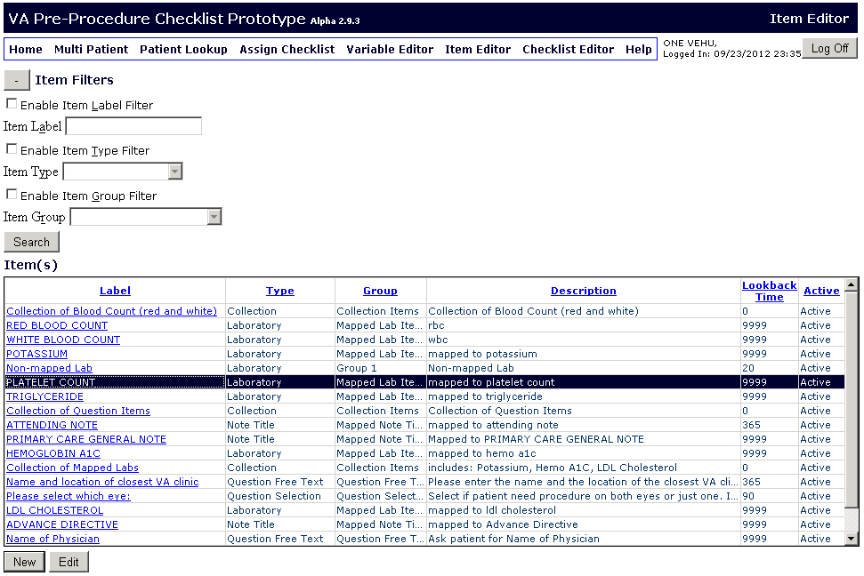

**Toggle Button to collapse item Filters area**

**Select item**

**from list and**

**Click ‘Edit’**

**Select Filter(s) and Criteria,**

**then click ‘Search’**

Figure - Item Editor Page

Clicking ‘Edit’ will cause the Item Editor dialog to appear populated with the selected item’s information, allowing the User to make any relevant changes. Once the changes have been made, the User can click ‘Save’ to save them. The User can click ‘Cancel’ to exit the dialog when done.

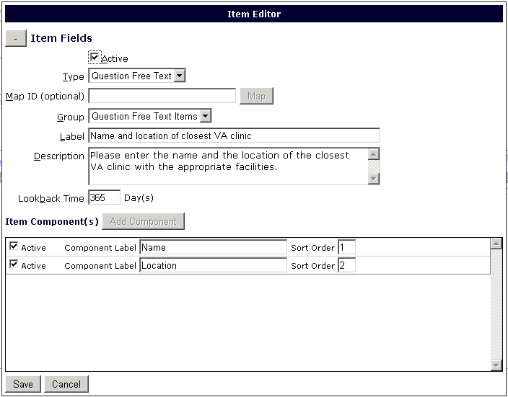

Figure - Pre-populated Item Editor Dialog

# Checklist Editor

The Checklist Editor page is where the User can create the checklists using the items and variables previously created. The User may add or edit checklists. The checklists can be designated as active or inactive.

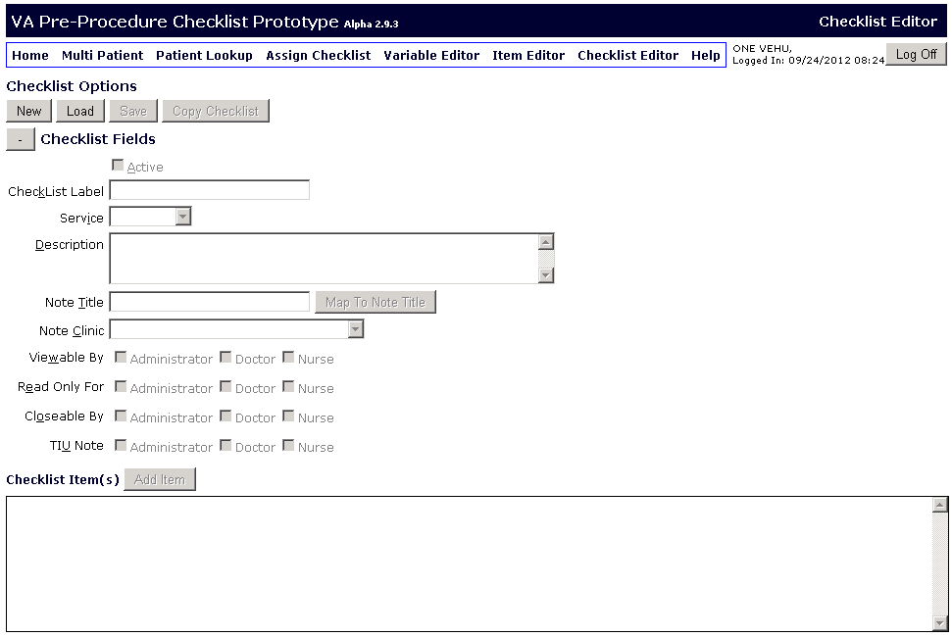

Figure - Checklist Editor

## Creating a New Checklist

To create a new Checklist the User enters the Checklist Editor and clicks on the ‘New’ button which enables all the fields. If the User has a checklist open already, the ‘New’ button can be clicked to clear the Checklist Editor fields and allow the User to enter new data. The User will enter a checklist label, service (the service category the list), and description. The User can map the Checklist to a Note Title (covered in the next section) and can assign it to a Note Clinic. The User will select whether the checklist is active or inactive. The User will also select which roles (Administrator, Doctor, or Nurse) will have the rights to view or close a checklist, or write a TIU note. The User can designate who will have ‘Read Only’ rights as well.

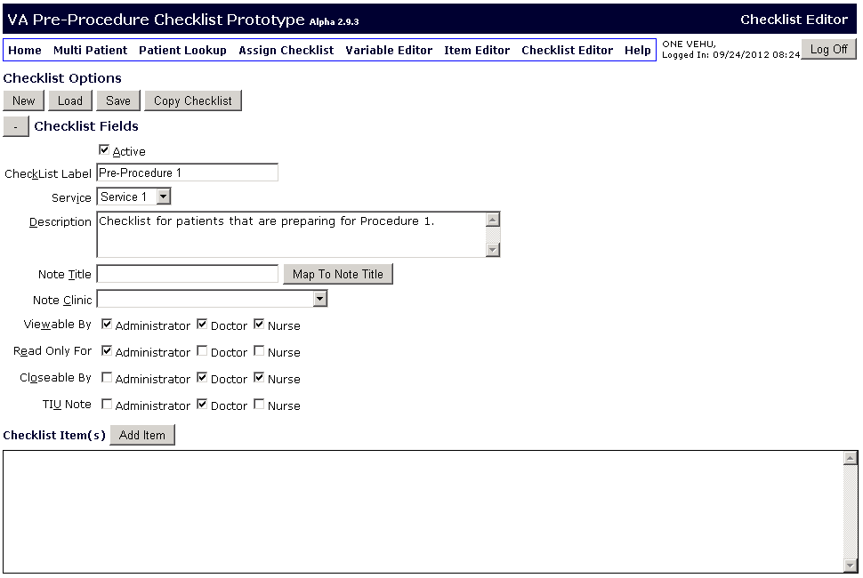

Figure - Checklist Editor New Checklist

### Mapping Checklist to Note Title

The User can select the note title to which they wish for the TIU note to be written with the contents of the checklist. The User can click on the ‘Map to Note Title’ to open the dialog with the list of available VistA titles.



**Click to**

**Access list of Note Titles for mapping**

Figure - Checklist Editor: Mapping to Note Title

The User can user the search function to search for the desired Note Title, or browse the list. The User can then click on the Note Title and click the Select button to assign that title.

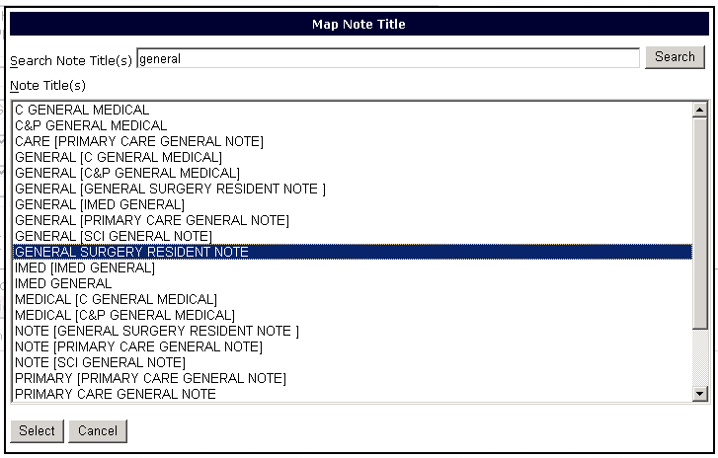

Figure - List of Note Titles

To add items to the Checklist, the User can save the checklist and then click on ‘Add Item’ which will cause the Item Selector dialog to appear.

The Item Selector dialog is used by the Checklist Editor page to add an existing item to checklist. A User may filter by all, some or none of the filter options in the dialog for a subset of items from the complete item list. The User can click on the label of the desired item and click ‘Select’ to add the item to the checklist.

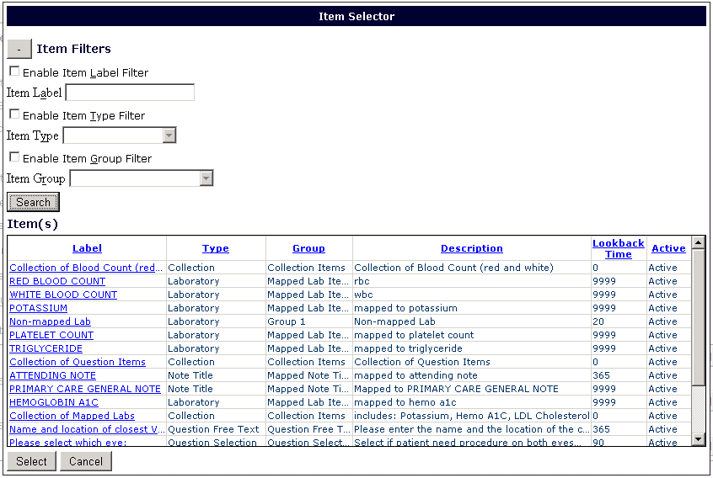

**Click item Label and ‘Select’ button to add item to Checklist**

**After selecting Filters/Criteria**

**click “Search”**

Figure - Item Selector Dialog

After selecting an item, the item information will populate in the item section of the Checklist Editor page.

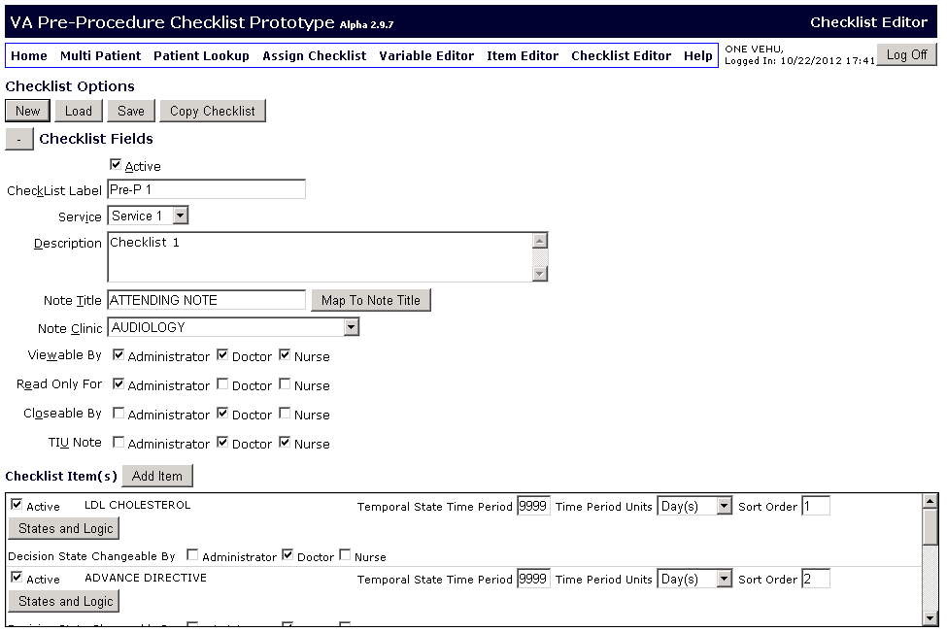

**User selects/enters relevant information for item**

**item(s) Box**

Figure - Checklist Editor with Item

The User will also select which roles (Administrator, Doctor, or Nurse) will have the rights to modify the Temporal, Outcome, and Decision states for the item. The User will also assign a Temporal State Time Period (the period of time within which the item must have been previously completed in order for results to be valid). The User will enter the number and units (days, hours etc) for the Temporal State Time Period. The User can enter the sort order in which they wish for the items to show up in the patient’s checklist.

The User can click on the toggle button to collapse the checklist fields and increase the viewing area for the list of items. The User can click ‘Save’ to save this information after it has been filled out. The ‘States and Logic’ button becomes enabled after saving an item to a checklist.

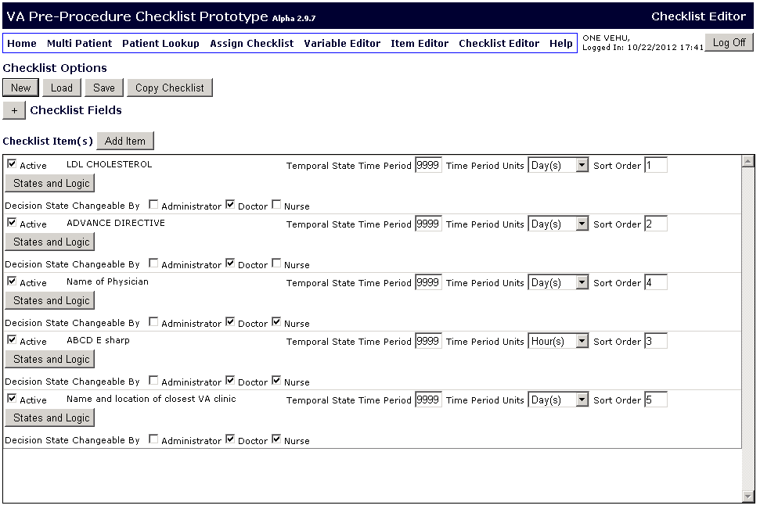

**Toggle Button**

Figure - Checklist Editor Collapsed Checklist Fields

### States and Logic Editor

Once enabled, the User can click on the ‘States and Logic’ button to add Temporal, Outcome, and Decision State variables to a checklist (in addition to the default variables) or to add custom logic.



**Click ‘States and Logic’ button to open ‘State/Logic Editor’**

Figure - Accessing State/Logic Editor

When the State/Logic Editor dialog appears, it displays the State Editor (the ‘State’ radio button is selected as a default). Here the User can add Temporal, Outcome, and Decision State variables to a checklist. There is a set of default variables that cannot be removed, but the User can place a checkmark beside any additional Temporal, Outcome, or Decision State variables they wish to include in the Checklist (or remove the check if they wish to remove the state from that Checklist). The User can click ‘Save’ when done.

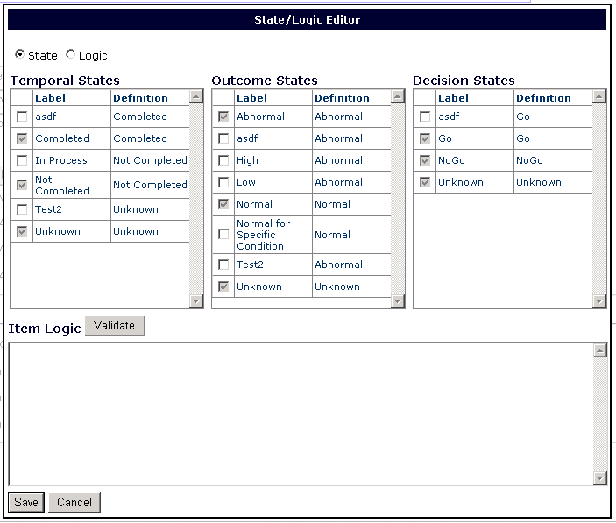

Figure - Checklist State/Logic Editor Dialog

The default variables are automatically selected and added to all checklists. When a User is done creating a checklist they can click the ‘Save’ button on the Checklist Editor Page.

#### Logic editor

In the State/Logic Editor the User can click on the ‘Logic’ radio button to access the logic builder tool.

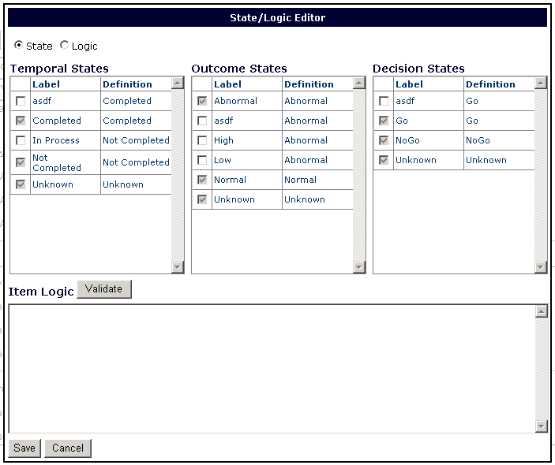

**Click ‘Logic’ radio button**

Figure 28 - State/Logic Editor

This builder aids the process of creating custom logic to designate relationships between the different states in addition to the default relationships, or to override them.

The User can select from Operators, Patient (demographics), Patient Items (items and corresponding Component attributes), Static data, and Actions they wish to take (Cancel a Checklist, Disable an Item, Set a Temporal, Outcome or Decision State).

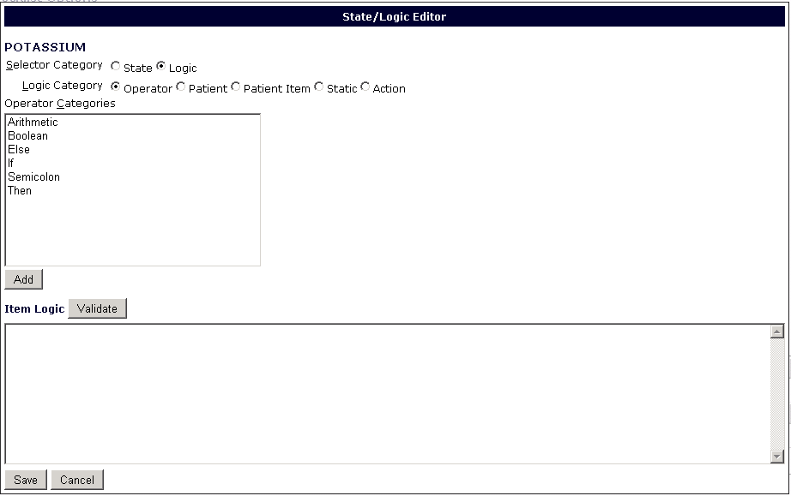

**Click on radio button to select**

Figure 29 - State/Logic Editor: Operators

The User can make a selection in the boxes on top and click ‘Add’ to add it to the box on the below. The last radio button includes the Actions that can result from meeting the conditions in the logic expression. In this example we will set the Decision State for this item to Go if the patient is female. The Operators (if, =, then) can be typed or added from the Operator radio button.

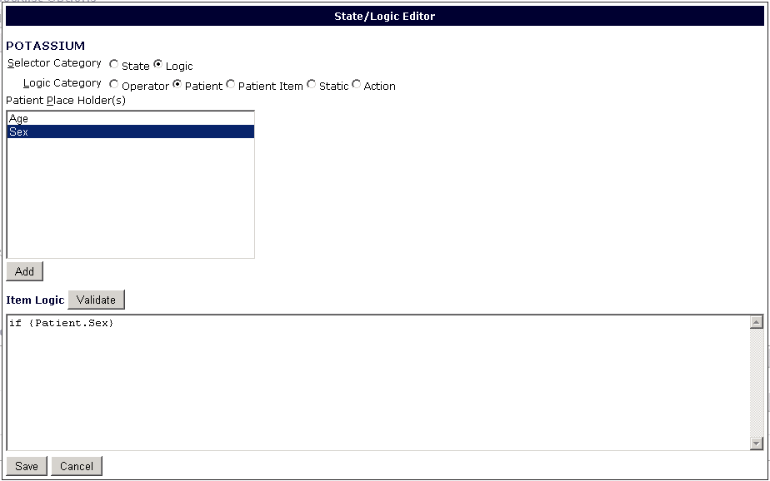Figure 30 - Selecting that Patient Sex is a Parameter

**Click on ‘Add’ to add selection to item Logic Box**

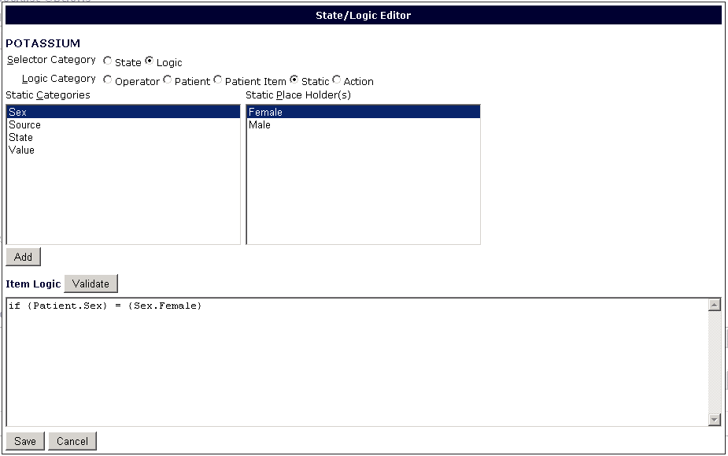Figure 31 - Selecting that Patient Sex must be Female

**When relevant new boxes with subgroups will appear for User to make a selection**

The Actions that are available are to Cancel the Checklist, Disable an item, or Set one of the States to a value. When done, the User can click the Validate button to see if there are any errors in the Logic expression.

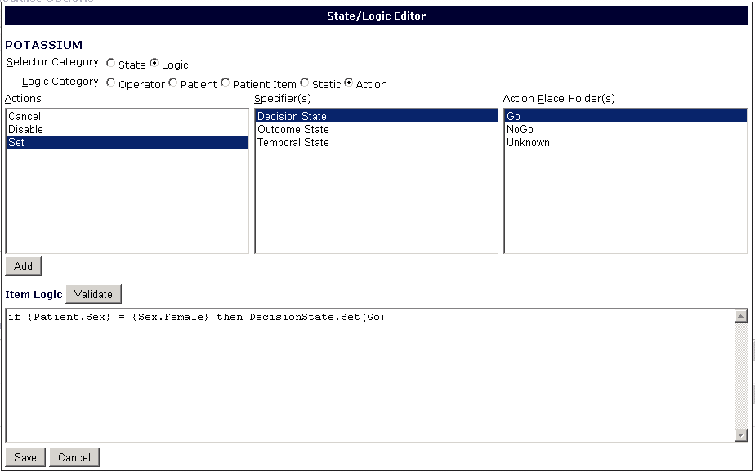Figure - Selecting the Action is to set the Decision State to Go

**Click here to Validate code**

## Editing a Checklist

If the User would like to load a previously saved checklist for viewing or editing they can to click the ‘Load’ Button, which will prompt the ‘Checklist Selector’ dialog to appear.

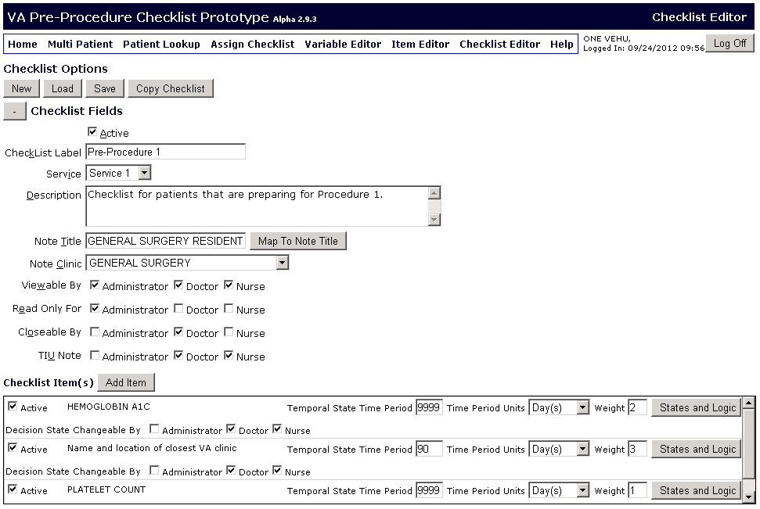

**Click ‘Load’ to pull up previously created checklist**

Figure - Checklist Editor Saving/Loading

The Checklist Selector dialog is used by the Checklist Editor page to load an existing checklist into the page for editing. A User may filter by all, some or none of the filter options in the dialog for a subset of checklist from the complete checklist list. The User can select the desired checklist and click “Select”. The information for the selected checklist will load in the Checklist Editor page.

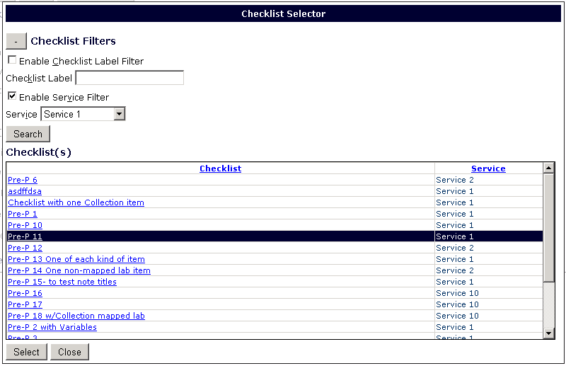

**Click on desired Checklist and click “Select”**

**After selecting Filters/Criteria**

**click “Search”**

Figure - Checklist Selector Dialog

After editing the checklist the User can save the changes to that checklist by clicking the Save button. If the User wishes to create a copy of a checklist, the User can load the checklist and click on the Copy Checklist button. This will cause the ‘Save Checklist as New Checklist’ dialog to open. The User can enter the desired label for the new checklist, and click Save. The new checklist is now saved.

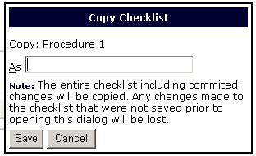

Figure - Save Checklist as New Checklist dialog

# Assign Checklist

The User can click on Assign Checklist in the navigation toolbar to go to the page where checklists can be assigned to patients.

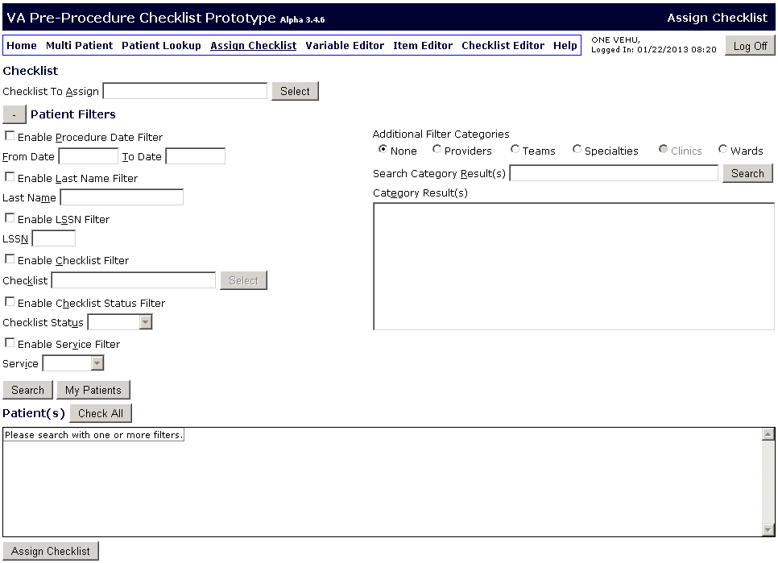

Figure - Assign Checklist page

The User can click on the ‘Select’ button next to the ‘Checklist to Assign’ field to open the Checklist Selector dialog. Here the User can filter by checklist name or service category and then click the ‘Search’ button to see a list of Checklists that meet the filter criteria. The User can then click on the desired checklist label and click ‘Select’ to select that checklist.



Figure - Checklist Selector Dialog

The User can search for patients using filters such as Last Name, LSSN (first initial of last name and last four numbers of their social security number), previously assigned checklists, and statuses of current checklists. To select a filter the User can place checkmarks in the boxes beside the desired filters and then enter the parameters. The User can also filter by the Vista parameters of Providers, Teams, Specialties, and Wards. To filter by Provider, the User clicks on the Provider radio button, enters the last name of the Provider whose patients they wish to look-up, and click search. A list of providers that match the search criteria will show up. To filter by the other criteria the User clicks on the radio button of the desired criterion and then a list will populate in the box below. The User can then click on the desired Team, Specialty, or Ward. The User can click ‘Search’ and the patients that match the parameters will be displayed in a list.

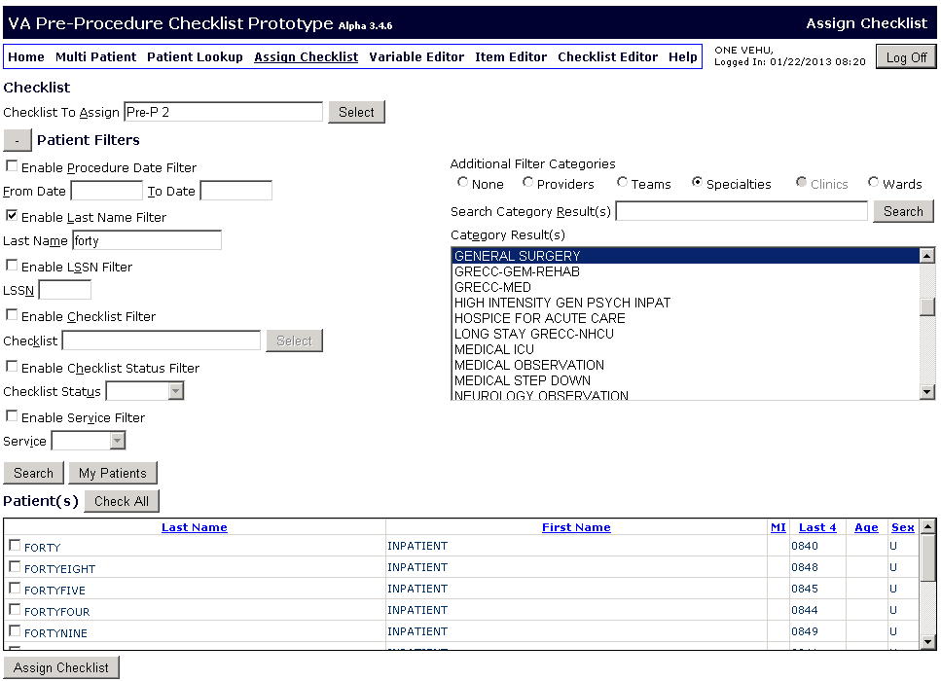

Figure - Assign Checklist: Patient Selected

The User can also click on ‘My Patients’ to pull up a list of patients assigned to the User that is logged in that meet the parameters that have been selected (this button can be used without selecting any filters and will provide a full list of patients assigned to the User that is logged in). User can place a checkmark in the boxes corresponding to the patients to whom they wish to assign the checklist. The User can also click on ‘Check All’ to select all patients in the search results. The User can then click on the ‘Assign Checklist’ button and the checklist will be assigned to the selected patients.

If the User attempts to assign a checklist to a patient that already has that checklist assigned to him, the User will get a window with a message letting them know this is the case and asking if they want to assign the checklist again. If the User wants to assign it again to all patient listed they just need to click ‘Yes’, if not, the User can click ‘No’. The User can assign it to only some of the patients on the list by removing the checkmark from the first column for the patients to whom they do not want to reassign the checklist, and then clicking ‘Yes’. Only the patients with the checkmark by their name will be reassigned the checklist.

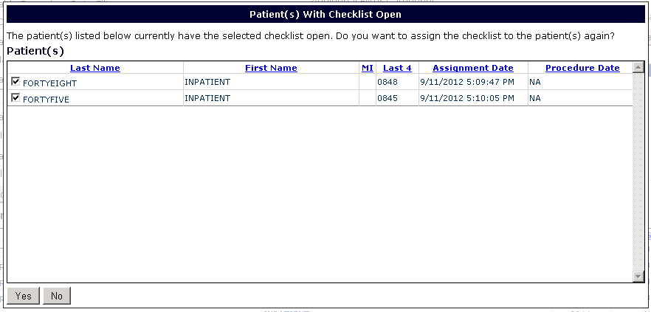

Figure - Warning Message Duplicate Checklists

A dialog will appear telling the User how many records remain for processing. If the User wishes to cancel processing the request, they can click on the ‘Cancel Processing’ button.

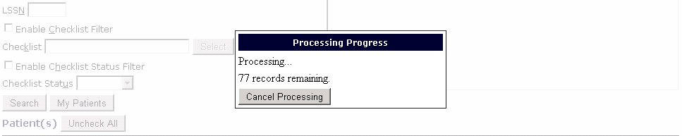

Figure - Cancel Processing

# Patient Lookup

The User can click on Patient Lookup on the navigation toolbar to look up an individual patient and access the Single Patient View page.

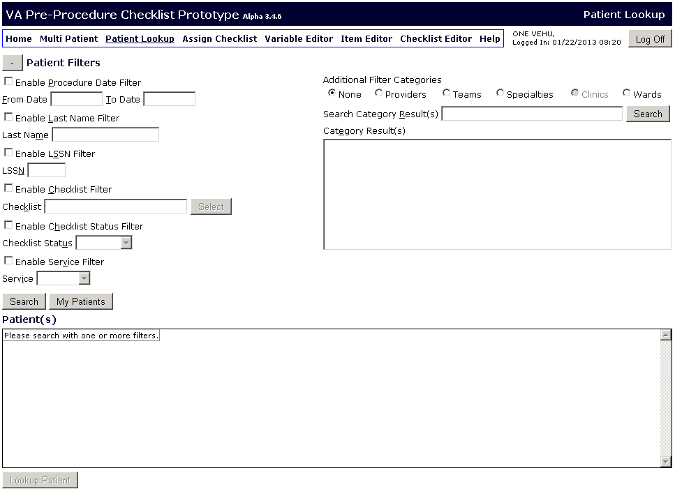

Figure - Patient Lookup Page

The User can search for patients using filters such as Last Name, LSSN (first initial of last name and last four numbers of their social security number), previously assigned checklists, and statuses of current checklists. To select a filter the User can place checkmarks in the boxes beside the desired filters and then enter the parameters. The User can also filter by Teams, Specialties, and Wards. To filter by Provider, the User clicks on the Provider radio button, enters the last name of the Provider whose patients they wish to look-up, and click search. A list of providers that match the search criteria will show up. To filter by the other criteria, the User clicks on the radio button of the desired criterion and then a list will populate in the box below. The User can then click on the desired Team, Specialty, or Ward.

The User can click ‘Search’ and the patients that match the parameters will be displayed in a list. The User can also click on ‘My Patients’ to pull up a list of patients assigned to the User that is logged in that meet the parameters that have been selected (this button can be used without selecting any filters and will provide a full list of patients assigned to the User that is logged in). The User can click on the patient to select them. The patient name will then be highlighted. The User can now click on the ‘Lookup Patient’ button to open the Single Patient View for that patient.

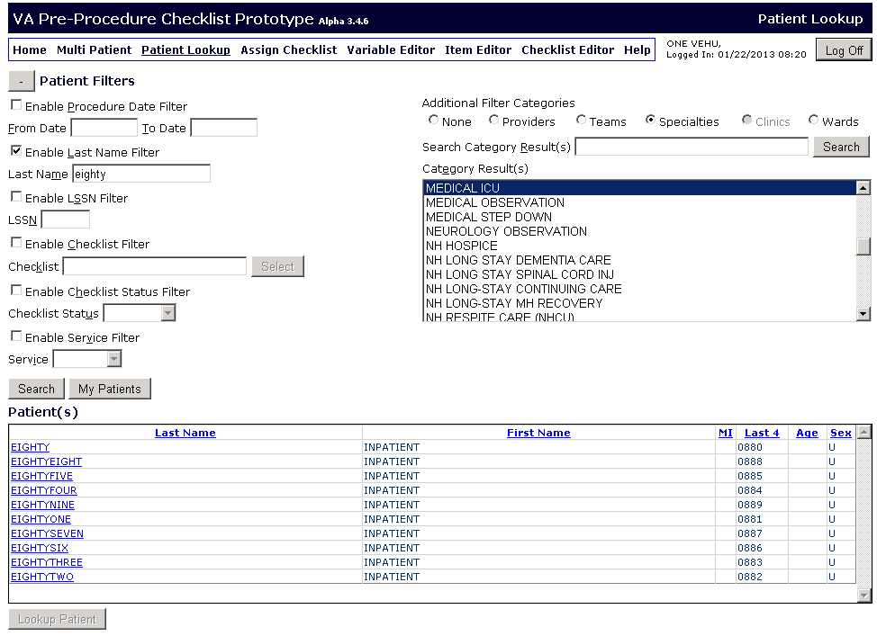

Figure - Patient Lookup: Patient Selected

# Single Patient View

The Single Patient View is the view where the User may see the current status of a checklist for a patient. A User may change the refresh time of the data or force a refresh at any time. A summary of the patient’s information is displayed at the top. The User can assign a checklist to the patient by clicking on the ‘Assign New Checklist’ button.

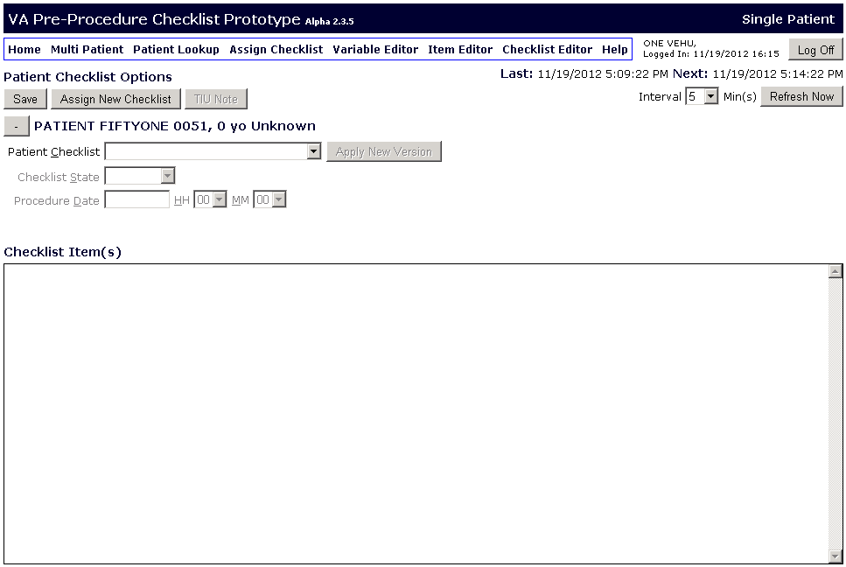

Figure - Single Patient View

If the User wants to view a patient’s checklist they can go to the ‘Patient Checklist’ dropdown menu which will display all checklists that have been assigned to the patient. Next to each checklist in the drop down menu the User will be able to see if the checklist is open, closed, or cancelled. Once the User clicks on the checklist name, the checklist items will populate the Checklist item(s) window. The Checklist Status and Procedure date and time will be enabled so the User can make changes in these fields. Override button is denoted by Ovr, update by Upd, and trend by Trd.

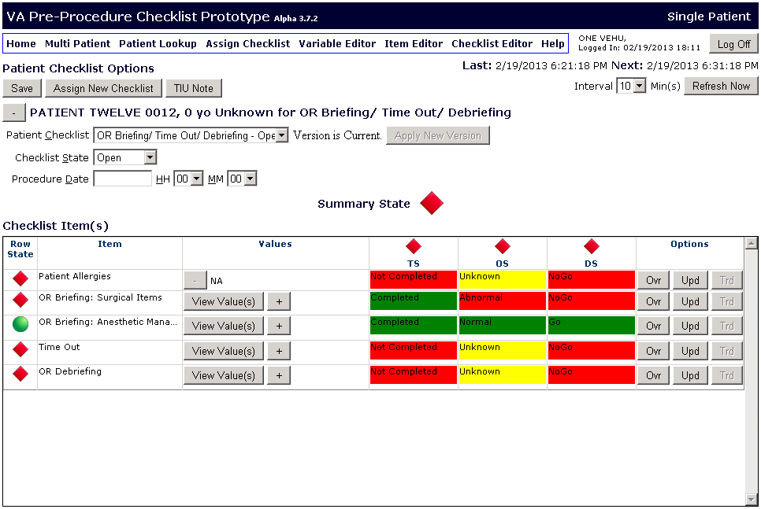

**Toggle Button**

**Currently Assigned Checklist List**

**Override, Update, and Trend buttons**

Figure - Single Patient View with Open Checklist

The User can set a refresh interval for the checklist and the application will automatically check the local database for any new data periodically at that rate.  If the User clicks the “Refresh Now” button at any time, the application will contact MDWS and retrieve from VistA the latest data for the currently open checklist.  The User can click on the toggle button beside the patient name to hide the checklist name, state, and date fields in order to have a larger viewing area.

## Updating Items

To update any checklist item the User can click on the ‘Update’ button for than item. This will cause the Single Patient Item Editor dialog to appear. In this dialog the User can enter the data for the component when relevant or view and add comments to data that has been imported from VistA. The User can set the date and time for the entry of this data and they can enter a comment. The User can also view previous values for that component by clicking on the ‘Results’ drop down menu and selecting a date/time. Once the User is done entering information they can click ‘Save’.

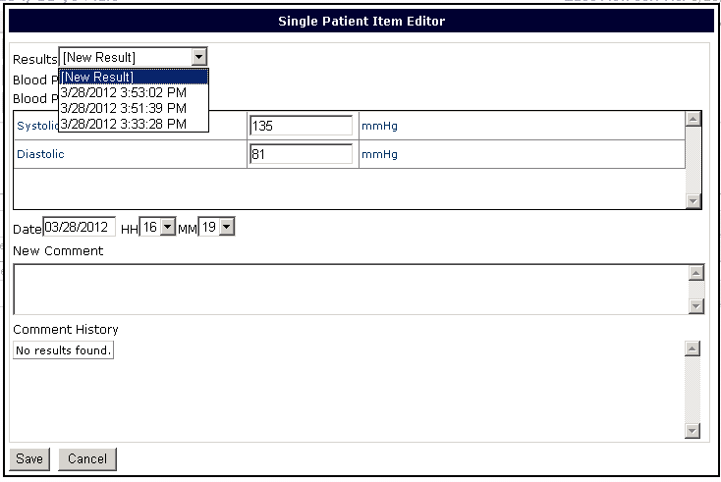

Figure - Single Patient Item Editor

The User can click on the ‘Trd’ (trend) button to view the historical trend of the item.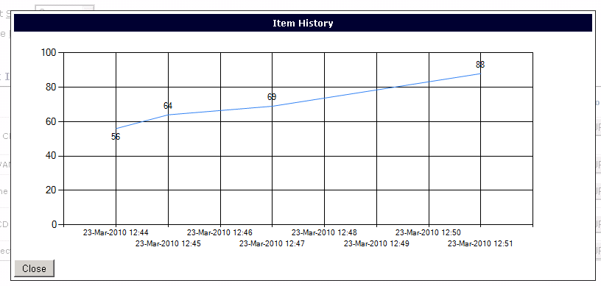

Figure - Data Historical Trend

### Collection Items

A User can Update Collection Items one of two ways. After clicking Upd, the User can either select an item to update from the ‘Collection Items(s):’ drop-down menu or the User can click on ‘Quick Entry’ to access a view where all the items in that collection can be updated.

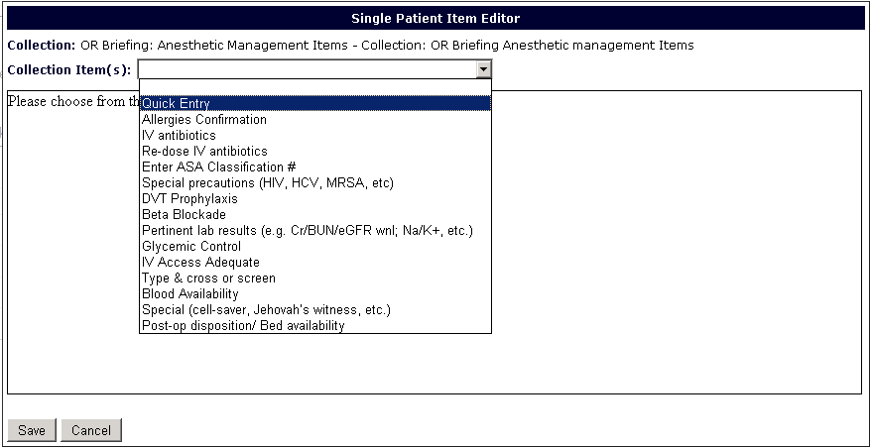

Figure - Collection Item Quick Entry

The User can then enter updates for all the items in the Collection by scrolling through the items and making corresponding selections. Quick Entry is for Collections with Question Selection and Free Text Question Items.

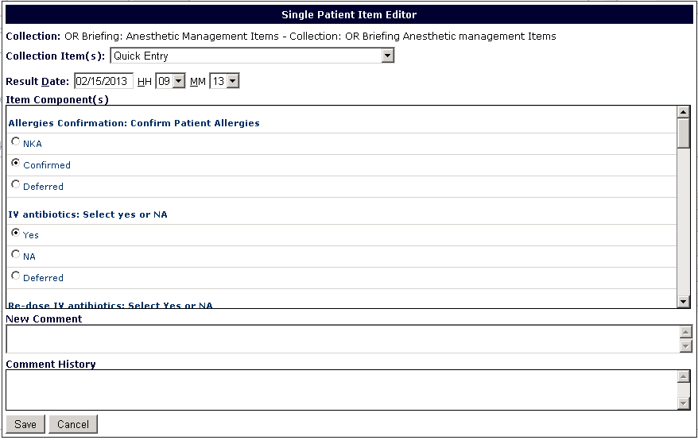

Figure - Entering Updates Quick Entry

The User can view the values for the Collection Item by clicking on the ‘View Value(s)’ button in the Values column of the Checklist. 

**Click to View item Values**

Figure - Checklist with Collection Items

A dialog will appear displaying the item labels and their most recent value. The User can utilize the scroll bar on the right of the dialog to view all items in the dialog.

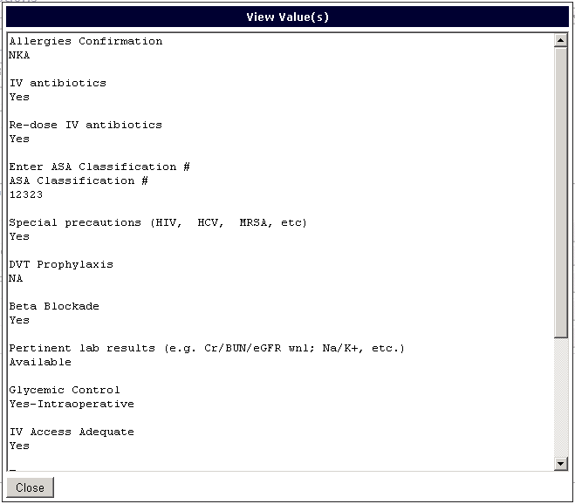

Figure - View Values

The User can view at a glance the status of the Decision State for all items in the Collection by clicking on the ‘+’ sign next to the ‘View Value(s)’ button. The User will be able to see the list of items and a symbol beside the item that corresponds to the item’s Decision State. A red diamond means the Decision State is set to NoGo, a green circle means the Decision State is set to Go, and a yellow triangle means the Decision State is set to Unknown.

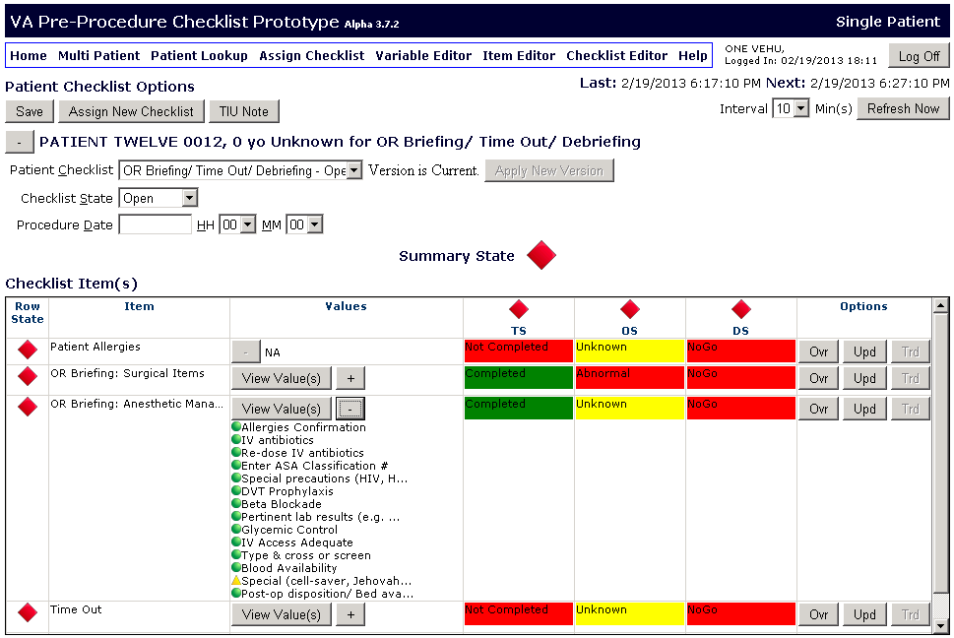

Figure - Collection item Values View

## Overriding Decision State

In order to manually override the Decision State for an item, the User can click on the ‘Ovr’ button in the item’s row. The ‘Override Patient Checklist Item State’ dialog opens and the User can select a different Decision State for the item. In order to save a variable override the User will be required to enter a comment in the comment section.

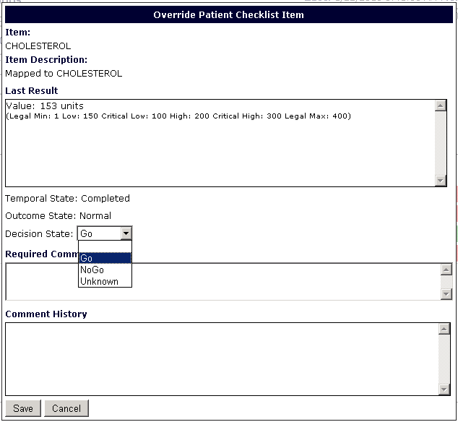

Figure - Override Patient Checklist Item State

After saving this information, the User will be taken back to the Single Patient View where they can see the status of the checklist.

The Temporal State (TS), Outcome State (OS), and Decision State (DS) columns each have visual indicators that display the overall state of the columns. If there is at least one incomplete/abnormal/NoGo state in the column, a red diamond will be displayed at the top of the column. If there is at least one unknown state, but no abnormal states, then the overall state will be unknown and a yellow triangle will be displayed at the top of the column. If all states are normal, the overall state will be normal and a green circle will be displayed.

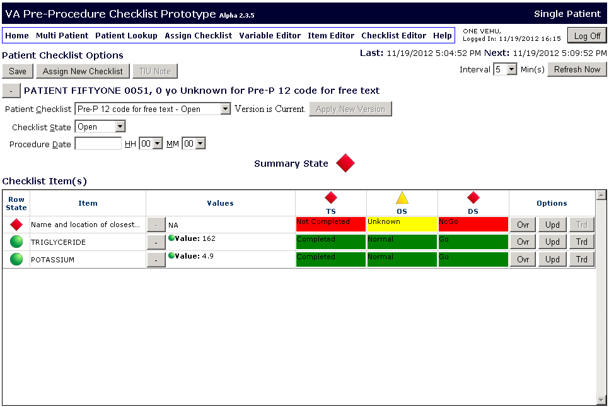

**Indicator Summarizes**

**State of Checklist**

Figure - Single Patient View with Open Checklist

Similarly, the overall state of each item is displayed at the beginning of each row. The Temporal State, Outcome State, and Decision State for the item in that row are aggregated and the visual indicator allows the User to know the overall state of the item. Any abnormal results for an item component will be displayed in the ‘Values’ column for that item. The User can click on the + button in a row to view all the data for the different components of an item.

The Summary State of the checklist will allow the User to know at a glance the overall state of the checklist. If at least one state in the checklist is incomplete/abnormal/NoGo, the Summary State indicator will display the red diamond. If all states are complete/normal/go, the Summary State indicator will display a green circle.

## Writing Checklist Contents to TIU Note

The User can write the contents of the Checklist to a TIU note by clicking on the TIU note button. The contents of the Checklist will be written to a note under the VistA Note Title that was previously selected in the Checklist Editor. The contents can be written while the Checklist is still open and/or while closing the Checklist.

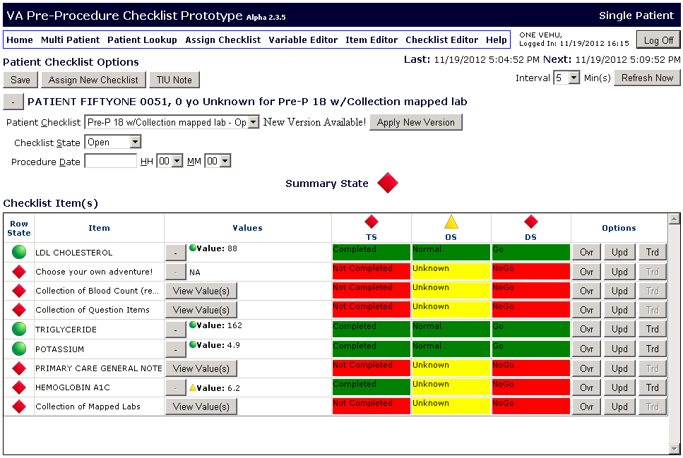

**Click here to create a TIU Note of the Checklist**

Figure - Single Patient View TIU Note

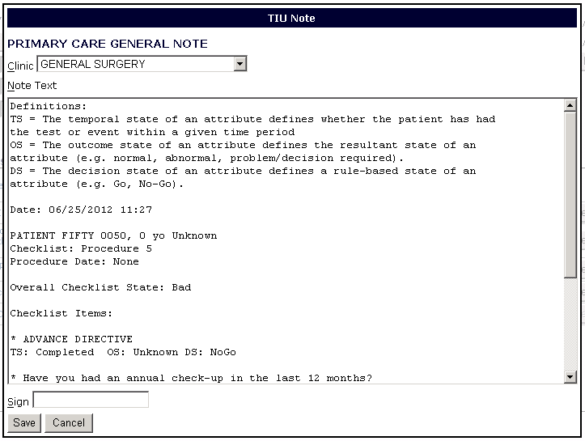

Figure - Sample TIU Note

## New Version Available

If a newer version of a checklist that has already been assigned to the patient becomes available a ‘New Version Available!’ message will appear beside the patient checklist name and the User can click on ‘Apply New Version’ to update the patient’s checklist. If an item had been overridden and has not changed from one version to the other, it will remain overridden. If an item has changed, the states will display based on the logic assigned to the item (default logic or custom).



Figure - New Version Available

If the User clicks on ‘Apply New Version’ a dialog will appear, letting the User know the dates of the current and new versions. The User can place a checkmark beside the checklist if they wish to update the checklist and click ‘Apply New Version.’

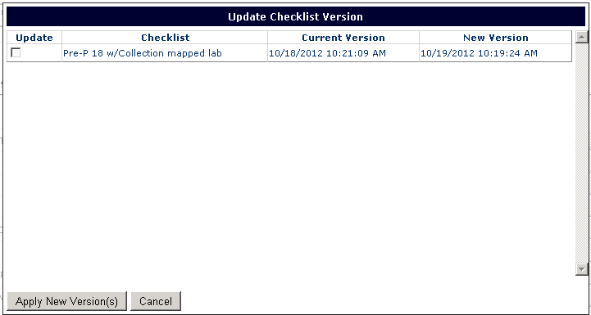

Figure - Update Version Dialog

If the checklist being used is the newest available, the message beside the title of the checklist will be ‘Version is Current.’ The ‘Apply New Version’ button will be disabled.



Figure - Version is Current

# Multi Patient View

The Multi Patient View is the view where a User may look at checklist summaries for multiple patients. The User may filter by all, some or none of the filter options in the view for a subset of patients from the complete patient list.

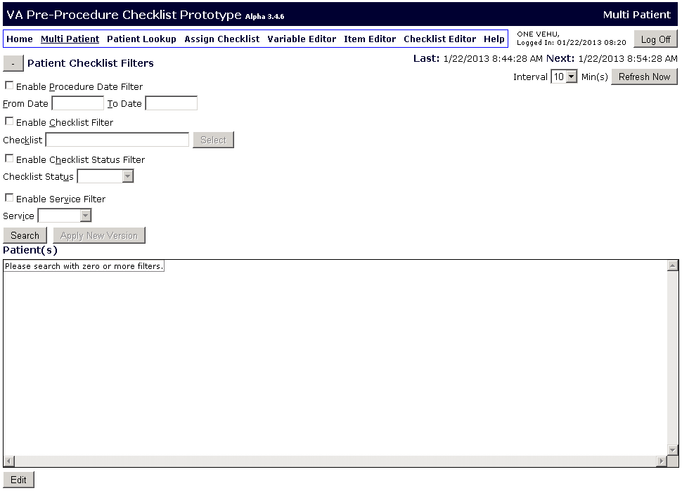

Figure - Multi Patient View

The states of the items in the patient’s checklist are aggregated underneath the groups they were assigned to. The rows and columns of the checklist grid are aggregated into the visual indicators at the end of the rows and columns. If nine out of ten items are complete and one is abnormal the aggregation will display abnormal. If ten out of ten items are complete the aggregation will display complete.

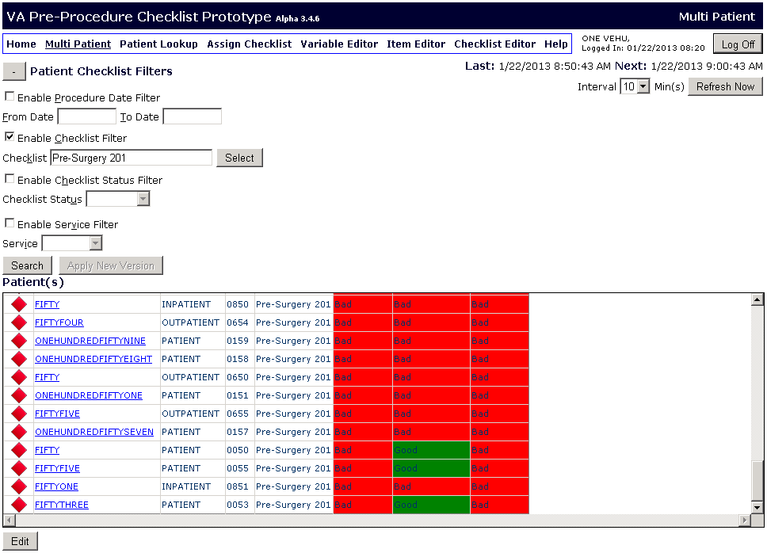

Figure - Search Results Multi Patient View

## Multi Patient View Refresh

The Multi Patient view will automatically refresh locally at an interval that can be set by the User. The User can see the date and time of the last automatic refresh, labeled ‘Last:’ and the date and time for which the next automatic refresh is scheduled, labeled ‘Next:’. The User can select the interval from the dropdown menu. There is a ‘Refresh Now’ button that allows the User to refresh the data to include the most recent data that has been entered both locally and from VistA.



**Refresh Information**

Figure - Data Refresh

After the User clicks ‘Search’ a dialog will appear telling the User how many records remain for processing. If the User wishes to cancel processing the request, they can click on the ‘Cancel Processing’ button.

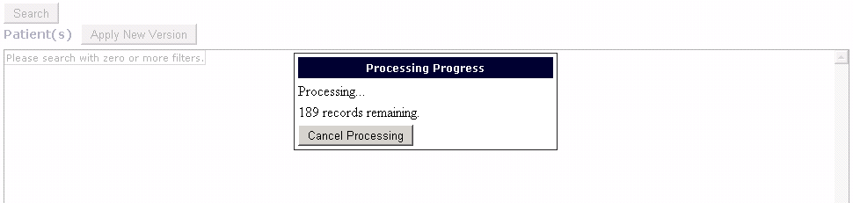

Figure - Cancel Processing

The User can click on the toggle button by the ‘Patient Checklist Filters’ title to hide all of the filters and increase the viewing area. Clicking the toggle button again will allow the User to view the filters again.

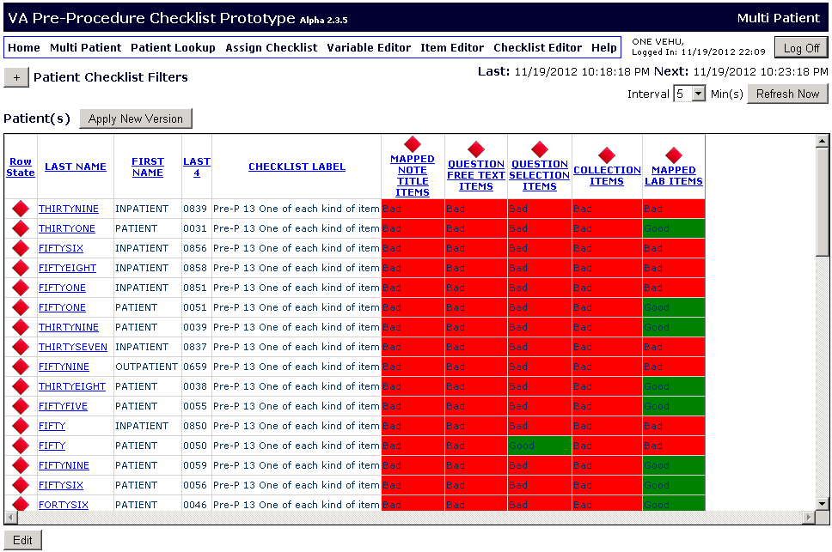

**Toggle Button**

**Select a Patient and Click ‘Edit’ to edit a patient’s checklist**

Figure - View After Collapsing Filters

A User may edit the checklist of a patient by clicking on the patient’s last name to select the patient and clicking on the ‘Edit’ button.

## Apply New Checklist Version to Multiple Patients

The User can click on ‘Apply New Version’ to view if any of the patients in the search results have a new version of their checklist available.

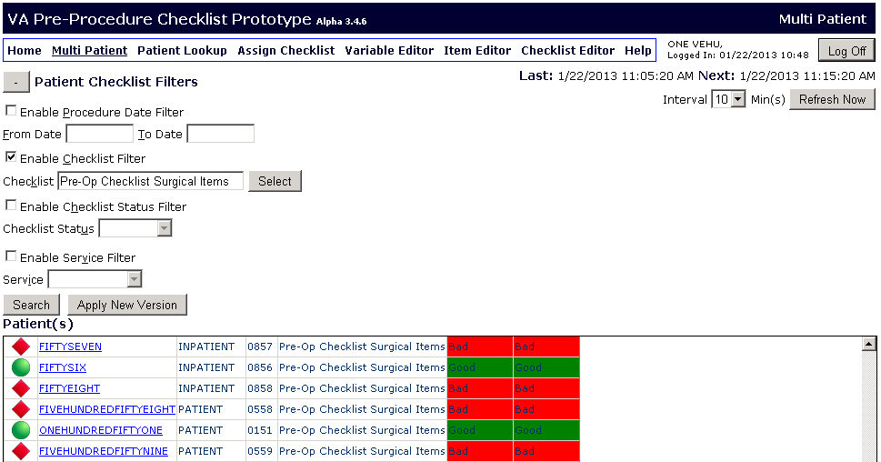

**Apply New Version**

Figure - Apply New Version

In the ‘Update Checklist Version’ dialog the User can place a checkmark beside any of the patients whose checklist the User wishes to update.

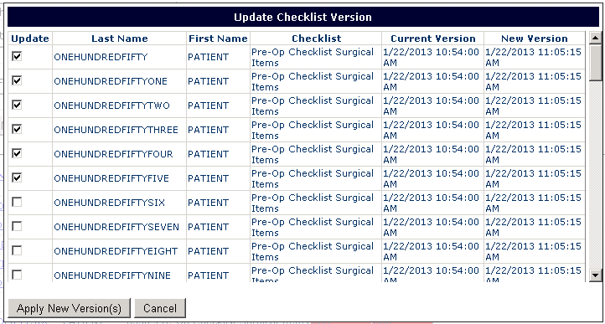

Figure - Apply New Version: Select Patients

## Single Patient Editor

Once the User clicks on the ‘Edit’ button for a patient, the Single Patient Editor opens for this patient. Here the User is able to view more details about the patient’s status. The User can click on the ‘Update’ button to update values for a patient’s item, or on the Override button to override the decision state for a patient’s item.

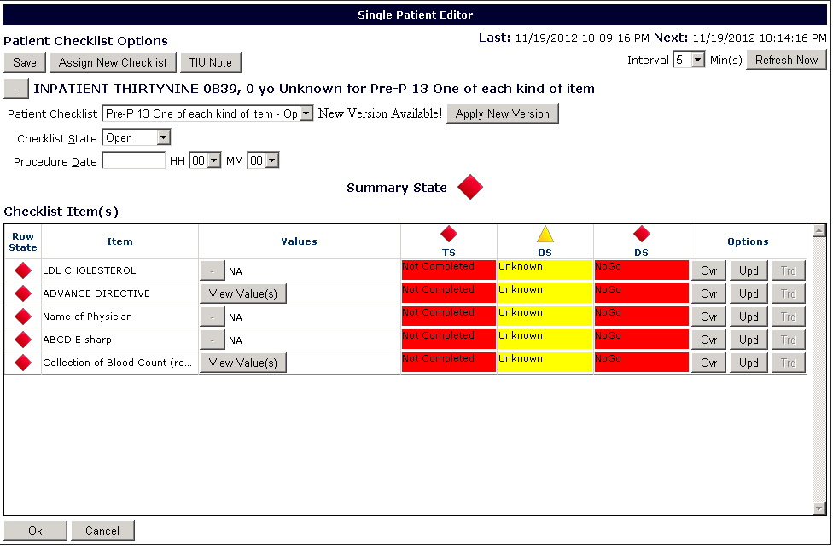

Figure - Single Patient Editor accessed from Multi Patient View